HLS ASSIGNMENT4[Kanekal kousar(fwc2022063)]

Q) Design a basic integer ALU unit in HLS that takes 3 inputs: Two 8bit operands and one appropriately sized operator. The permitted operations are ADD, SUB, MUL, DIV, AND, OR and XOR. Use AXI-S ports for all I/O ports. The design should be pipelined

 Run C simulation first and verify your design with multiple inputs from a file (you need to create this file as well) containing sets of above 3 inputs and 1 reference output to compare your design output in the testbench. The test bench should be a self-checking testbench. It should run the simulation, pass on inputs, compare the outputs with the reference outputs and write the outputs to another file, along with the Pass or Fail status of that particular test as obtained from the comparison. The testbench should also tell (after the simulation output in the console) at the end of the simulation if all the read input sets passed the test or not.

Header file:

|  |
| --- |
| **#ifndef** _HEADER_H_  **#define** _HEADER_H_  **#include** <hls_stream.h>  **using** **namespace** hls;  **#include** <ap_int.h>  **typedef** ap_int<8> int8_i;  **typedef** ap_int<16> int16_o;  **typedef** ap_uint<3> uint3_op;  **struct** inputs {  int8_i operandone;  int8_i operandtwo;  uint3_op operation;  };  **#endif** |

Function header file:

|  |
| --- |
| **#ifndef** _CALCI_H_  **#define** _CALCI_H_  **#include** "header.h"  int16_o **add**(inputs tmp);  int16_o **sub**(inputs tmp);  int16_o **mul**(inputs tmp);  int16_o **div**(inputs tmp);  int16_o **And**(inputs tmp);  int16_o **Or**(inputs tmp);  int16_o **Xor**(inputs tmp);  int16_o **add**(inputs tmp)  {  **return** tmp.operandone + tmp.operandtwo;  }  int16_o **sub**(inputs tmp)  {  **return** tmp.operandone - tmp.operandtwo;  }  int16_o **mul**(inputs tmp)  {  **return** tmp.operandone * tmp.operandtwo;  }  int16_o **div**(inputs tmp)  {  **return** tmp.operandone / tmp.operandtwo;  }  int16_o **And**(inputs tmp)  {  **return** tmp.operandone & tmp.operandtwo;  }  int16_o **Or**(inputs tmp)  {  **return** tmp.operandone | tmp.operandtwo;  }  int16_o **Xor**(inputs tmp)  {  **return** tmp.operandone ^tmp.operandtwo;  }  **#endif** |

C++ code:

|  |
| --- |
| **#include** "header.h"  **#include** "calci.h"  **void** **alu_8bit**(stream<inputs> &indata,stream<int16_o> &outdata){  **#pragma** HLS PIPELINE  **#pragma** HLS INTERFACE axis port=outdata  **#pragma** HLS INTERFACE axis port=indata  inputs data=indata.read();  **switch** (data.operation)  {  **case** 0:  outdata.write(add(data));  **break**;  **case** 1:  outdata.write(sub(data));  **break**;  **case** 2:  outdata.write(mul(data));  **break**;  **case** 3:  outdata.write(div(data));  **break**;  **case** 4:  outdata.write(And(data));  **break**;  **case** 5:  outdata.write(Or(data));  **break**;  **case** 6:  outdata.write(Xor(data));  **break**;  }  } |

Test bench:

|  |
| --- |
| **#include** "header.h"  **#include** <iostream>  **#include** <fstream>  **using** **namespace** std;  **void** **alu_8bit**(stream<inputs> &indata,stream<int16_o> &outdata);  **int** **main**(){  stream<inputs> indata;  stream<int16_o> outdata;  inputs data={0,0,0};  **int** op1,op2,op,res;  **char** arr[]={'+','-','*','/','&','|','^'};  **int** case_fail=0;  //reading input data from in.dat file and writing output to out.dat file  ifstream in;  fstream out;  in.open("in.dat");  out.open("out.dat");  **while** (in>>op>>op1>>op2>>res){  data={op1,op2,op};  indata.write(data);  alu_8bit(indata,outdata);  int16_o O=outdata.read();  **if** (O==res){ out<<data.operandone<<arr[data.operation]<<data.operandtwo<<"="<<O<<"\t\tpass"<<**endl**;  }  **else**{  case_fail++;  out<<data.operandone<<arr[data.operation]<<data.operandtwo<<"="<<O<<"\t\tfail"<<**endl**;  }}  **if** (case_fail==0){  cout<<"---all test case passed---"<<**endl**;  }  **else**{  cout<<"---"<<case_fail<<" test case failed---"<<**endl**;  }  in.close();  out.close();} |

In.dat file out.dat file

|  |  |
| --- | --- |
| 1 2 3 -1  4 3 4 0  2 4 5 20  5 5 6 7  1 6 7 -1  3 9 8 1  4 7 9 1  2 9 10 90  4 10 11 10  3 11 12 0  2 12 13 156  5 13 14 15  6 14 15 1  6 16 17 1  0 1 18 19  3 16 8 2 | 2-3=-1 pass  3&4=0 pass  4*5=20 pass  5|6=7 pass  6-7=-1 pass  9/8=1 pass  7&9=1 pass  9*10=90 pass  10&11=10 pass  11/12=0 pass  12*13=156 pass  13|14=15 pass  14^15=1 pass  16^17=1 pass  1+18=19 pass  16/8=2 pass |

Synthesis report

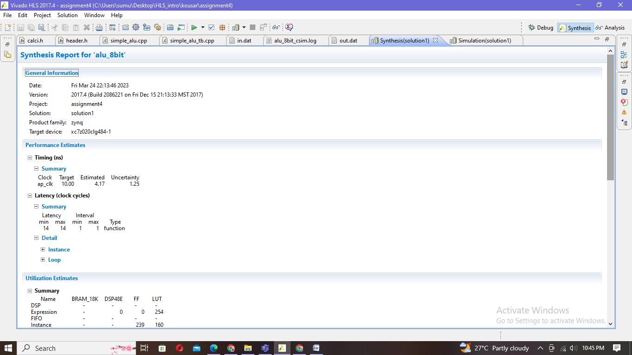

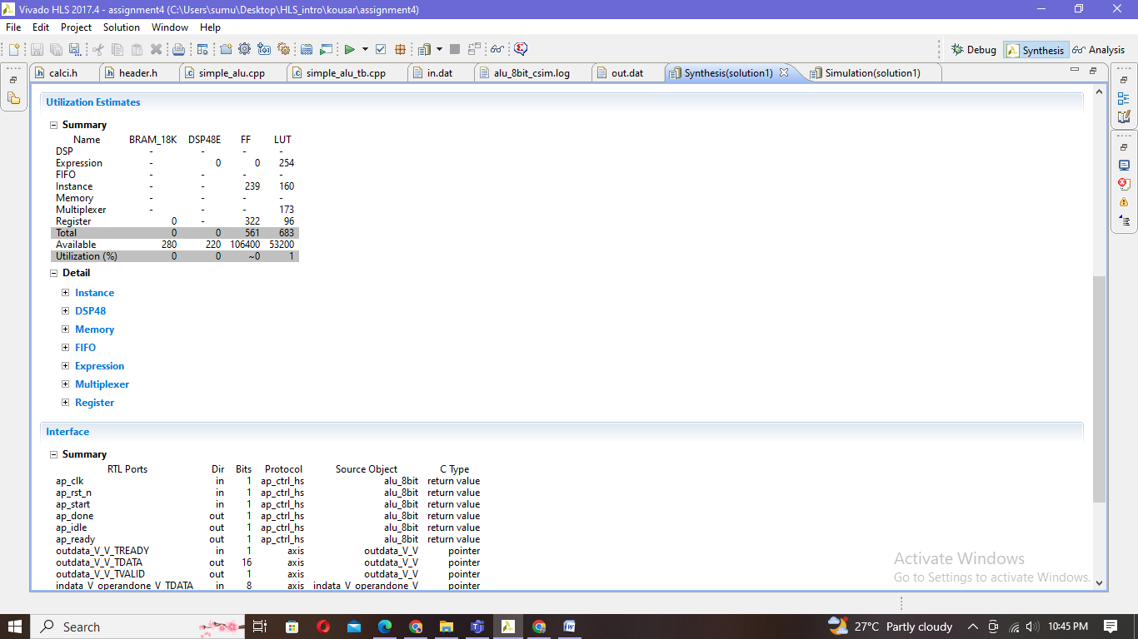

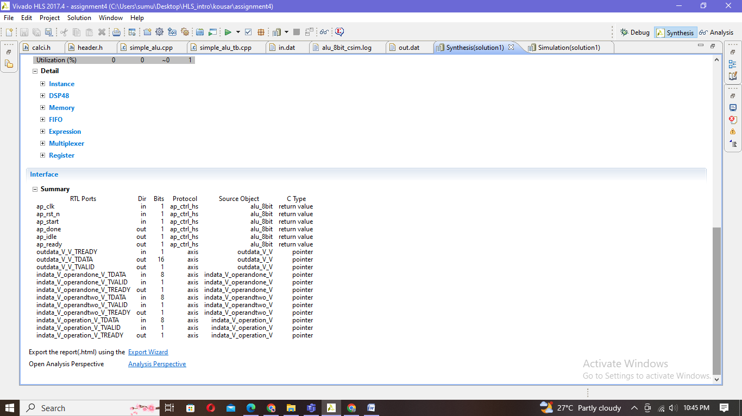

Simulation:

|  |
| --- |
| INFO: [SIM 2] *************** CSIM start ***************  INFO: [SIM 4] CSIM will launch GCC as the compiler.  make: `csim.exe' is up to date.  ---all test case passed---  INFO: [SIM 1] CSim done with 0 errors.  INFO: [SIM 3] *************** CSIM finish *************** |

Co-simulation:

|  |
| --- |
| INFO: [Common 17-206] Exiting xsim at Fri Mar 24 23:06:33 2023...  INFO: [COSIM 212-316] Starting C post checking ...  ---all test case passed---  INFO: [COSIM 212-1000] *** C/RTL co-simulation finished: PASS ***  Finished C/RTL cosimulation |

